
http://missbacon.free.fr/4e/Banksy/Banksyawebquest.html

VIDEO 1 : THE TECHNIQUE OF BANKSY
1- Stop at 3:10 : Name the different objects/ustensils you need to paint like Banksy (mentioned in the video)
a) un modèle | b)  | c)  | d) 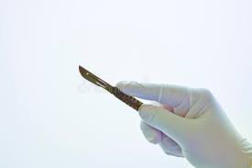
a d___________ or  a printed p_________ | a s__________ : you can use acetate sheets. You will need 4/5 l__________ | m_________ t________ | a _______________
e) 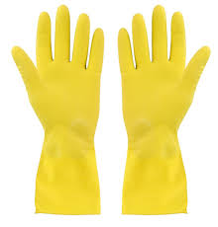 | f)  | g) 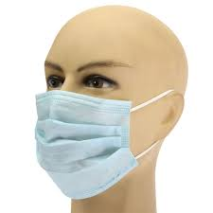 | h) 
____________ | s__________ c________ | a _______ m_______ | a c___________

HELP to cut out = découper to spray = pulvériser, vaporiser to run = couler, dégouliner

2-Look at the rest of the video : in your opinion, what is difficult in this technique ?
_______________________________________________________________________________________
_______________________________________________________________________________________

VIDEO 2 : Banksy does New York (trailer)
3-Watch from 0:00 to 0:30
-Is it difficult to remain anonymous today ? O Yes O No
-What was Banksy’s promise when he came to NY ?
It was to _______________________________________________________________________________

4-From 0:30 to 1.15
-What were the different types of work he did around the city ?
S__________, m_______ paintings, and « i_____________ » : for example : a painting on a c____, a truck

filled with a__________, a b_________ car with Death in it. It was like « s________ theater »
-How did people react ? What did they do ?
______________________________________________________________________________________
______________________________________________________________________________________
-What is really cool about street art ? ________________________________________________________
______________________________________________________________________________________

5-From 1:15 to 1:40
-Who reacted to Banksy’s action ? ___________ = N_______ Y________ P_________ D________________
-Why ? _________________________________________________________________________________
______________________________________________________________________________________

6-From 1:40 to the end
-What happened to some of Banksy’s works ?
_______________________________________________________________________________________
______________________________________________________________________________________
-What did it sometimes lead to (provoke) ?
______________________________________________________________________________________
HELP an auction = vente aux enchères

VIDEO 3 : Bristol 2009 Exhibition (répondre au dos, en français)
Observe les différentes œuvres exposées :
7-Comment Banksy arrive-t-il à interpeller le spectateur ?
8-Quelles thématiques sont récurrentes ? En quoi est il un artiste engagé ?

